Remote Control Hacker
Devinder Saini

This circuit allows the user to capture and replay binary waveforms of finite length. It can be used to capture signals of a TV remote, RF remotes (garage openers, car remotes) etc and replay them.

Device used is mega8515 operating at 8Mhz.

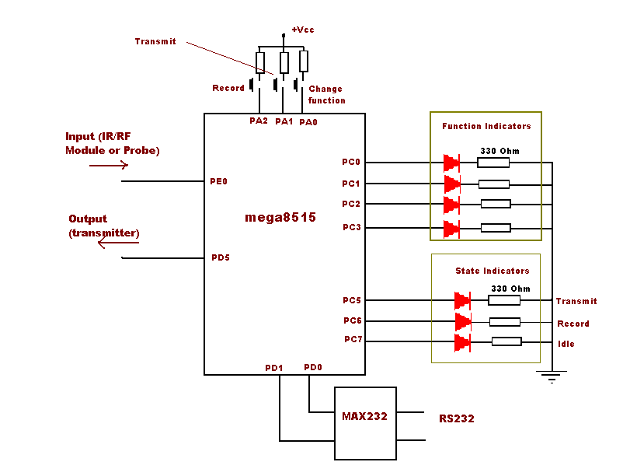

The program is currently optimized for recording TV Remote signals. To use it for TV IR signals, use an IR module such as TSOP1738 at input and 555 timer coupled with IR LEDs.
Function can be selected using function selector switch connected at PA0.
PA1 will transmit the function and PA2 initiates a recording.

When system is in recording mode, it will look for a change in the waveform at the input. As soon as it senses one, it starts the timer and captures each event with a time stamp.
After recording is complete, data can be logged to computer through RS232 interface.

On playback, timer is started and timer output is matched to successive time stamps recorded earlier and sets the output pin accordingly.

System is currently programmed to look for a high to low transition at start. It can be changed easily by slightly modifying a setting as instructed in the source code.
Settings can be changed by altering “define”s at the beginning of the code.

Program code is made using Codevision AVR C Compiler.

Circuit was only tested for TV remote signals and worked fine.

